**Write a program in .NET to show the use of Write() and Redirect() method.**

using System;

using System.Collections.Generic;

using System.Linq;

using System.Web;

using System.Web.UI;

using System.Web.UI.WebControls;

public partial class A1 : System.Web.UI.Page

{

protected void btnwelcome_Click(object sender, EventArgs e)

{

Response.Redirect("A2.aspx");

}

}

**-----------------------------------------------------------------OUTPUT--------------------------------------------------------------**

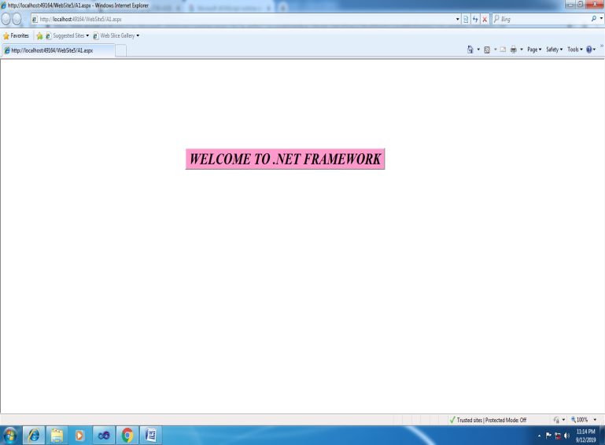

using System;

using System.Collections.Generic;

using System.Linq;

using System.Web;

using System.Web.UI;

using System.Web.UI.WebControls;

public partial class A2 : System.Web.UI.Page

{

protected void btnback_Click(object sender, EventArgs e)

{

Response.Redirect("A1.aspx");

}

protected void btnarchitecture_Click(object sender, EventArgs e)

{

Response.Redirect("A3.aspx");

}

protected void btnplinq_Click(object sender, EventArgs e)

{

**-----------------------------------------------------------------OUTPUT--------------------------------------------------------------**

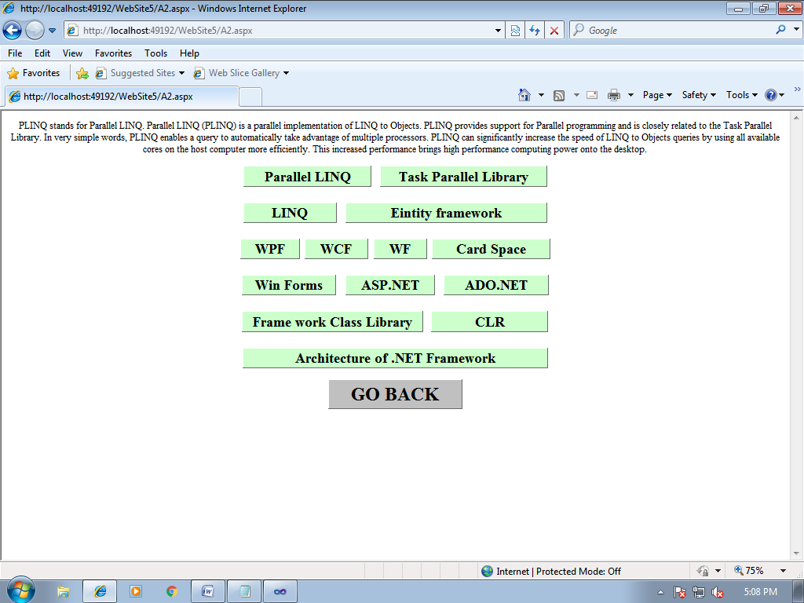

using System;

using System.Collections.Generic;

using System.Linq;

using System.Web;

using System.Web.UI;

using System.Web.UI.WebControls;

public partial class A3 : System.Web.UI.Page

{

protected void btngoback_Click(object sender, EventArgs e)

{

Response.Redirect("A2.aspx");

}

}

**-----------------------------------------------------------------OUTPUT--------------------------------------------------------------**

